Connecting Azure App to TSOHost

Two things

- Purahces a domain (example.com)
- Go to Custom Domains
- “Add Custom Domain on other DNS”
- -enter domain name (example.com)
- Generate TXT code
- Go to provider (eg TSOHOst) and enter in the TXT with TTL set to 3600.
- maybe 10-15 minutes will pass and azure will say the domain is validated.

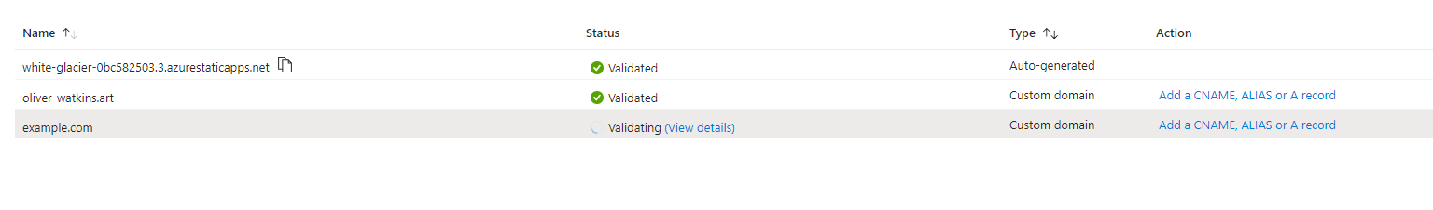
- Next go to Add a CNAME, ALIAS or A record
- Go to “A”
- Copy the IP address
- And add a record like so (Optionally you can also add the “www” subdomain)

